AI in Medical Service and Health Care

Thi ngoc Phung Cao / Soyeong Yi
2025.11.07
Index

- Introduction
- Overview of SkinVision
- Data & Preprocession
- Core Algorithms
- Evaluation Mertics
- Testing SkinVision
- Conclusion
- Positive
- Negative
- Reference

Ⅰ. Introduction
In dermatology, the application of AI in skin cancer screening and diagnosis has been developed. This has become possible thanks to Deep Learning CNNs. Recent developments in CNNs enable AI models to integrate clinical data, analyze multiple lesions simultaneously, and learn from whole-slide images without manual annotation.

Ⅱ. Overview of SkinVision
SkinVision is an artificial intelligence-based application that can detect skin cancers from photos. It provides an easy way for ordinary people to screen for skin cancer. The app divides skin lesions into three risk categories and provides users with personalized advice about making a consultation with dermatologists.

Ⅲ. Data & Preprocessing
The dataset contained many images of skin lesions collected from dermatological sources. Each image was resized and normalized. Simple filters were used to remove noise. The lesion area was segmented using a U-Net model or cropped around the center of the image. Augmentation methods such as rotation, flipping, and contrast adjustment were applied. All images were converted to RGB, and their pixel values were scaled between 0 and 1. Low-quality or mislabeled images were removed.

Ⅳ. Core Algorithms
The SkinVision uses a deep learning model based on Convolutional Neural Networks (CNNs) to analyze smartphone images of pigmented skin lesions. The CNN extracts features such as color, shape, and border irregularity to classify lesions into low, medium, or high-risk categories. In a study of 1,204 lesions, the algorithm achieved “sensitivity 41–83 %, specificity 60–83 %, and AUROC 0.62–0.72, lower than dermatologists (AUROC > 0.90).” ^{[1]}
According to a systematic review by Freeman et al. (2021) in the British Journal of Dermatology, several smartphone apps, including SkinVision, were evaluated for diagnostic accuracy. The results showed high variability and limited reliability among these AI-based apps. In particular, some SkinVision studies were funded by the company itself, raising
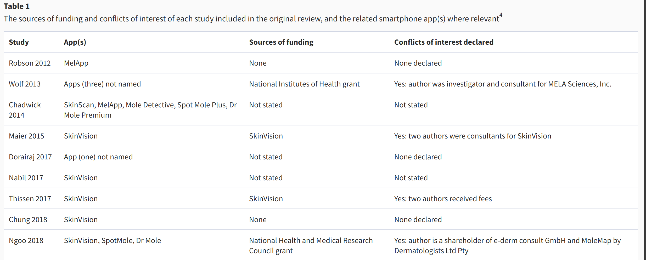
Picture 1. The sources of funding and conflicts of interest of each study included in the original review, and the related smartphone app(s) where relevant ^{[2]}

Ⅴ. Evaluation Metrics
In a study of 1,204 skin lesions, the SkinVision classified 19 % as suspicious, while dermatologists found only 0.7 %. This means the app produced a 27-fold higher rate of melanoma-suspect cases.
The over-detection reflects the app’s lower specificity and higher tendency for false positives, which could lead to unnecessary anxiety or excisions. Nevertheless, such results demonstrate how AI-based tools like SkinVision can enhance screening awareness but still require dermatologist validation to ensure clinical reliability.

Ⅵ. Testing SkinVision
This is a video demonstration of how to use the app.
How to use SkinVision? - YouTube

Ⅶ. Conclusion

i. Positive
The SkinVision shows the potential of AI in healthcare by making skin cancer screening more accessible. Its CNN-based algorithm supports early self-assessment and has shown sensitivity up to 87 % and specificity around 80 % in controlled studies.

Ii. Negative
In real-world settings, accuracy is lower than dermatologists (sensitivity 41–83 %, specificity 60–83 %, AUROC 0.62–0.72). The app often over-detects high-risk lesions, causing false positives, and some company-funded studies raise concerns about bias and the need for independent validation

Ⅷ. Reference
[1] Greis, C., Lallas, A., Tschandl, P., Menzies, S., Marghoob, A., Blum, A., Rinner, C., et al. (2022). Over-Detection of Melanoma-Suspect Lesions by a CE-Certified Smartphone App: Performance in Comparison to Dermatologists, 2D and 3D Convolutional Neural Networks in a Prospective Data Set of 1204 Pigmented Skin Lesions Involving Patients’ Perception. PLOS ONE / PMC. https://pmc.ncbi.nlm.nih.gov/articles/PMC9357134/
[2] Freeman, K., Dinnes, J., Chuchu, N., Takwoingi, Y., Bayliss, S. E., Matin, R. N., ... & Deeks, J. J. (2020). Algorithm‐based smartphone apps to assess risk of skin cancer in adults: critical appraisal of a systematic review. British Journal of Dermatology, 183(2), 167–180. https://academic.oup.com/bjd/article/184/4/638/6603041
[3] Sharma, Y., Sinha, S., & Kaur, P. (2021). Skin Cancer Detection and Classification Using Neural Network Algorithms: A Systematic Review. Cancers, 13(17), 4314. PubMed Central (PMC). https://pmc.ncbi.nlm.nih.gov/articles/PMC8430617/

IV. Link Github
CUT/Lab_01 at Elements_of_Artificial_Intelligence · NgocPhungggg/CUT

